|  |  |
| --- | --- |
| **Canon EOS R6 + Lens 24-105mm f/4-7.1**  Máy ảnh Canon EOS R6 + Lens 24-105mm f/4-7.1  Canon EOS R6 with 24-105 f4-7.1 lens 2 Canon EOS R6 6 Canon EOS R6 7 Canon EOS R6 4 | **Featured information:**   * DIGIC X image processor/XQD * 20MP full-frame CMOS sensor * 5-axis image stabilization * Record 10-bit 4K 60p and FHD 120p video   Price: 2000$  **Specifications:**   * **Sensor Format:** Full-Frame (1x Crop Factor) * **Resolution:** 20.1 megapixels * **Size photo:** 5472 x 3648 * **Image Proportions:** 3:2 * **Sensor Type:** CMOS * **Image Format:** JPEG, Raw, HEIF * **Anti-Vibration:** Sensor-Shift, 5-Axis * **Lens Mount:** Canon RF |

**Description:**

#### **20.1MP CMOS & DIGIC X Sensor ON CANON EOS R6**

Canon EOS R6 is a Canon camera equipped with a 20.1 megapixel Full-frame CMOS sensor, which has been improved compared to the same sensor found on the 1DX mark III professional DSLR line. Combined with the DIGIC

#### **Some outstanding features in the design of the Canon EOS R6**

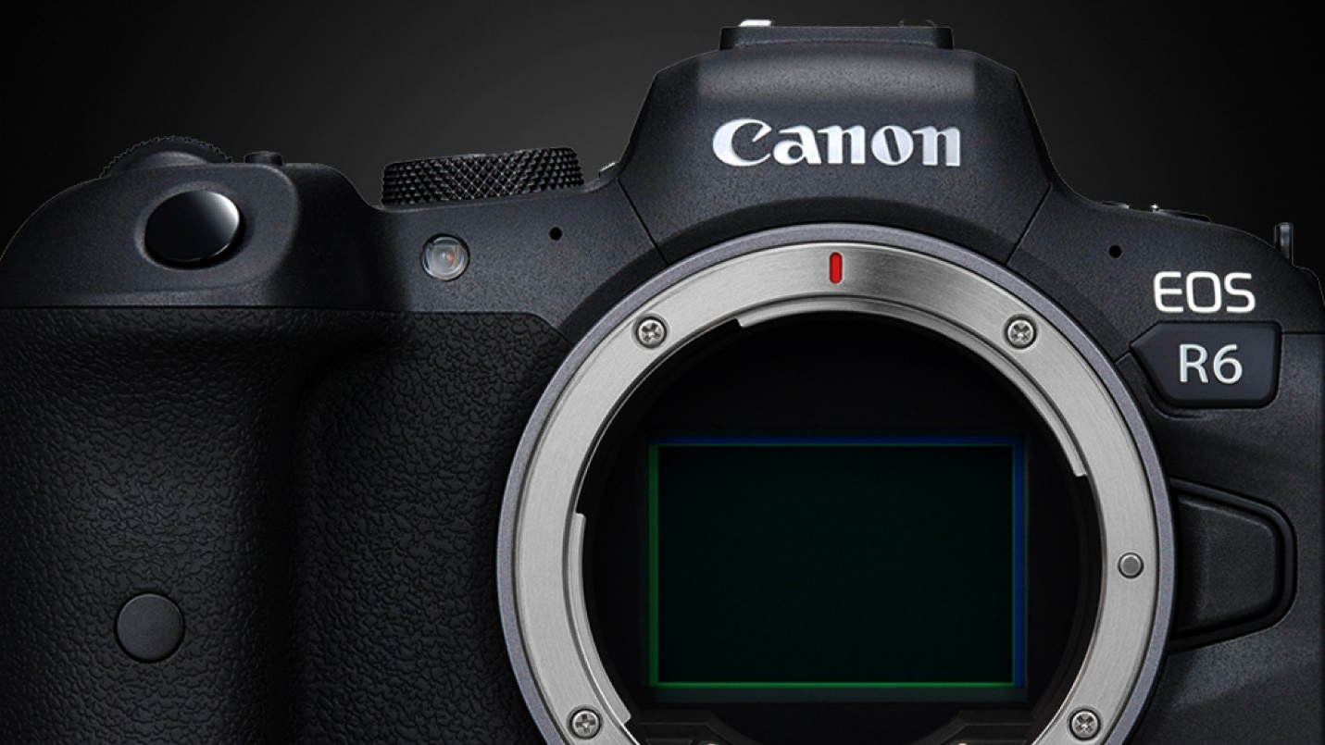

In addition to taking high-quality photos, the 20MP sensor of the Canon EOS R6 Full-frame mirrorless camera also supports 10-bit video recording with a 4:2:2 ratio of UHD 4K quality at a speed of up to 60 frames per second and Full HD at 120 fps. Both formats can be shot with Canon Log and HDR-PQ modes that support greater control over color rendering and provide high dynamic range.

